**Assignment -3**

|  |  |
| --- | --- |
| Assignment Date | 10th October 2022 |
| Team ID | PNT2022TMID34648 |
| Maximum Marks | Marks |

**Questions:**

1.Create a Bucket in IBM object storage.

2.Upload 5 images to IBM object storage and make it public. write html code to displaying all the 5 images.

3.Upload a CSS page to the object storage and use the same page in your HTML code.

4.Design a chatbot using IBM Watson assistant for hospital. Ex: User comes with query to know the branches for that hospital in your city. Submit the web URL of that chat bot as a assignment.

5.Create Watson assistant service with 10 steps and use 3 conditions in it. Load that script in HTML page.

**Question-1:**

**Create a Bucket in IBM object storage.**

**Solution:**

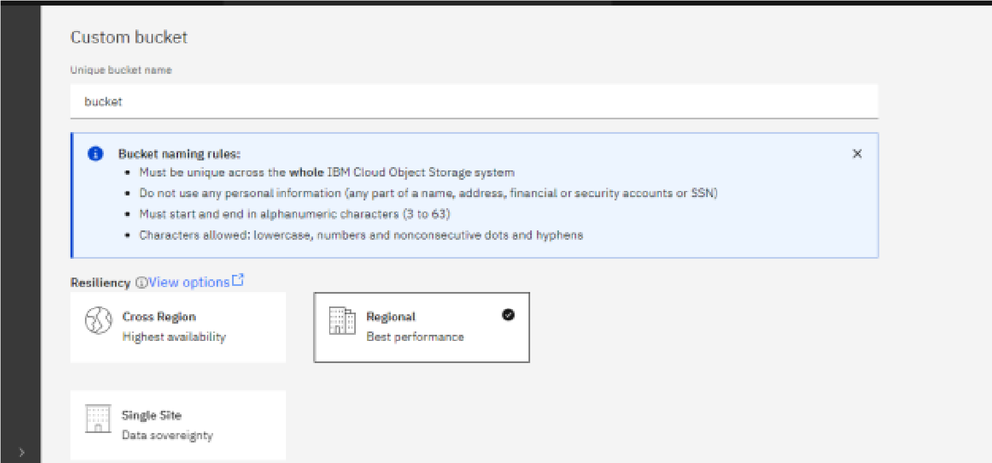

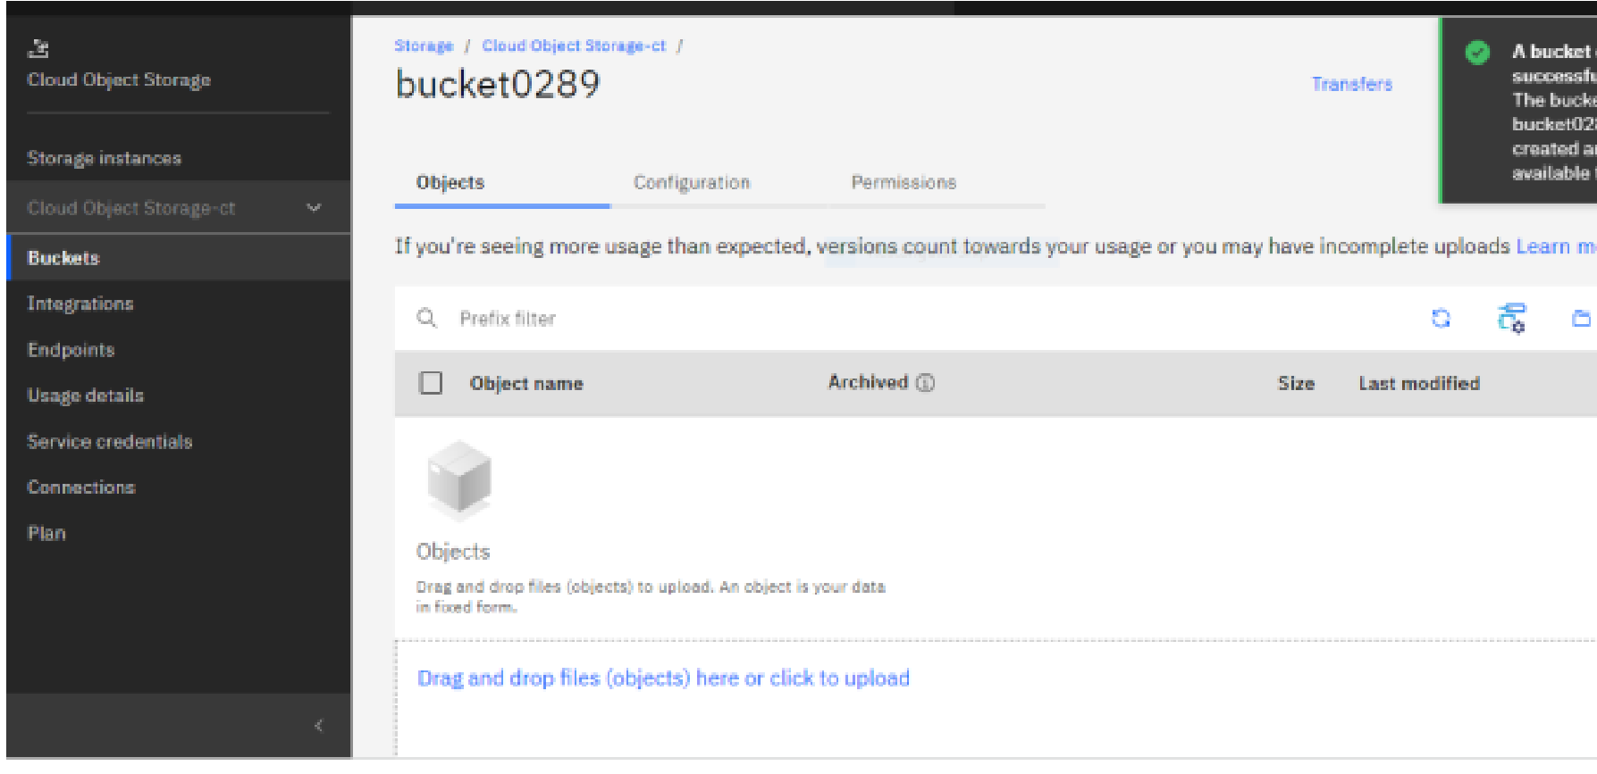

**Question-2:**

**Upload 5 images to IBM object storage and make it public. write html code to displaying all the 5 images.**

**Solution:**

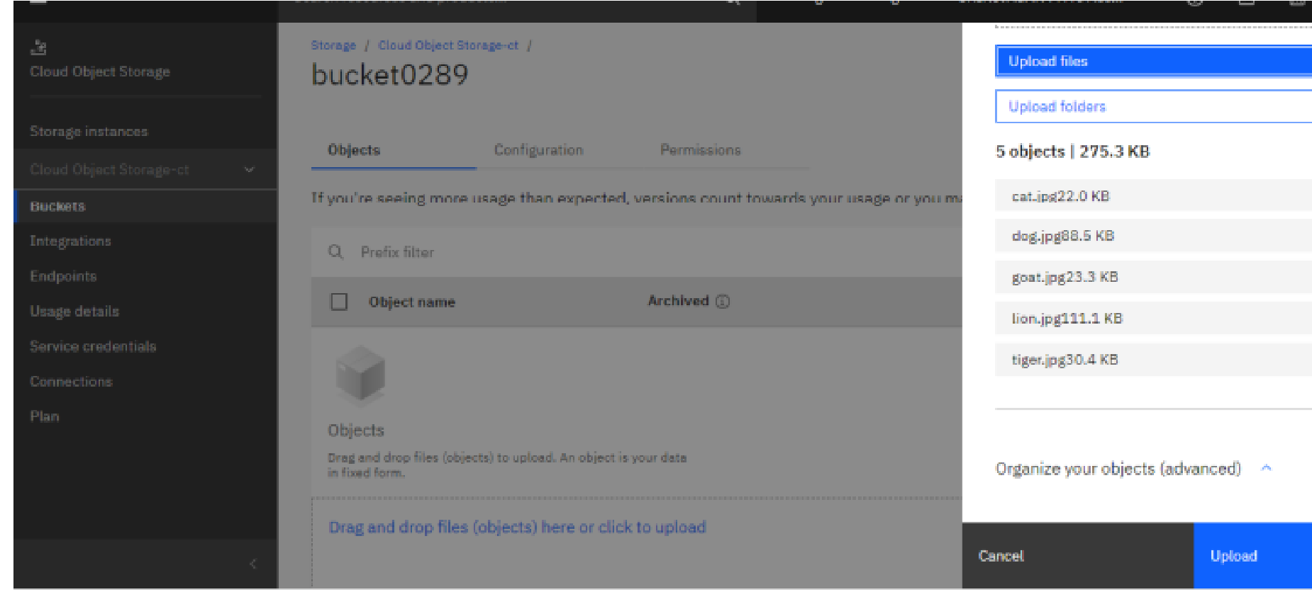

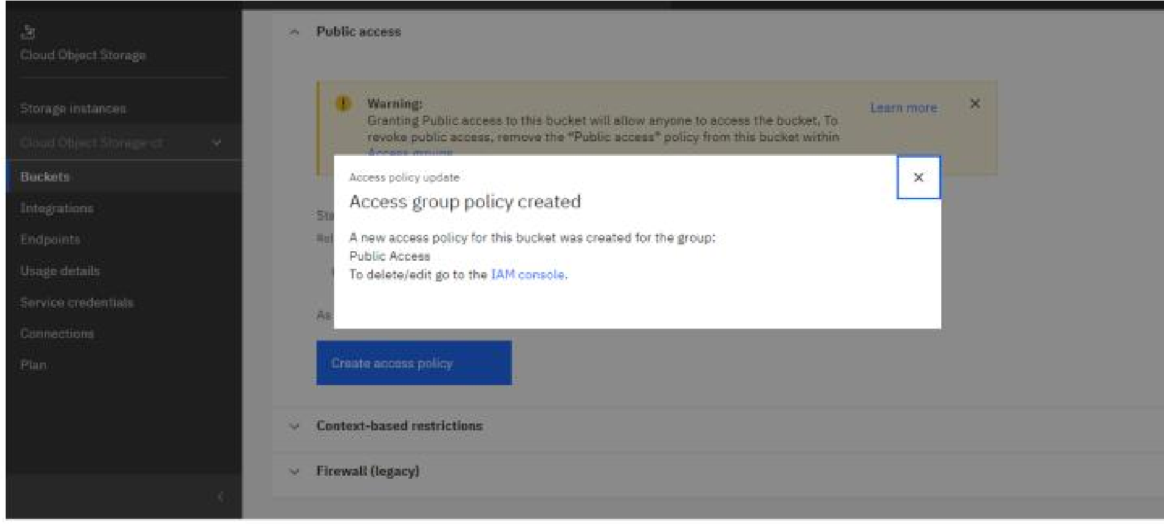

**CODE:**

<!DOCTYPE html>

<html>

<head>

<title>

Display Images

</title>

<link rel="stylesheet" href="style.css">

</head>

<body>

<h2>Images From Cloud Object Storage</h2>

<img src="https://bucket0289.s3.jp-tok.cloud-object-storage.appdomain.cloud/cat.jpg" alt =

"cat" style="width:350px;height:450px;"></img>

<img src="https://bucket0289.s3.jp-tok.cloud-object-storage.appdomain.cloud/dog.jpg" alt =

"dog" style="width:350px;height:450px;"></img>

<img src="https://bucket0289.s3.jp-tok.cloud-object-storage.appdomain.cloud/tiger.jpg" alt =

"tiger" style="width:450px;height:450px;"></img>

<img src="https://bucket0289.s3.jp-tok.cloud-object-storage.appdomain.cloud/lion.jpg" alt =

"lion" style="width:300px;height:400px;"></img>

<img src="https://bucket0289.s3.jp-tok.cloud-object-storage.appdomain.cloud/goat.jpg" alt =

"goat" style="width:300px;height:400px;"></img>

</body>

</html>

**Question-3:**

**Upload a css page to the object storage and use the same page in your HTML code.**

**Solution:**

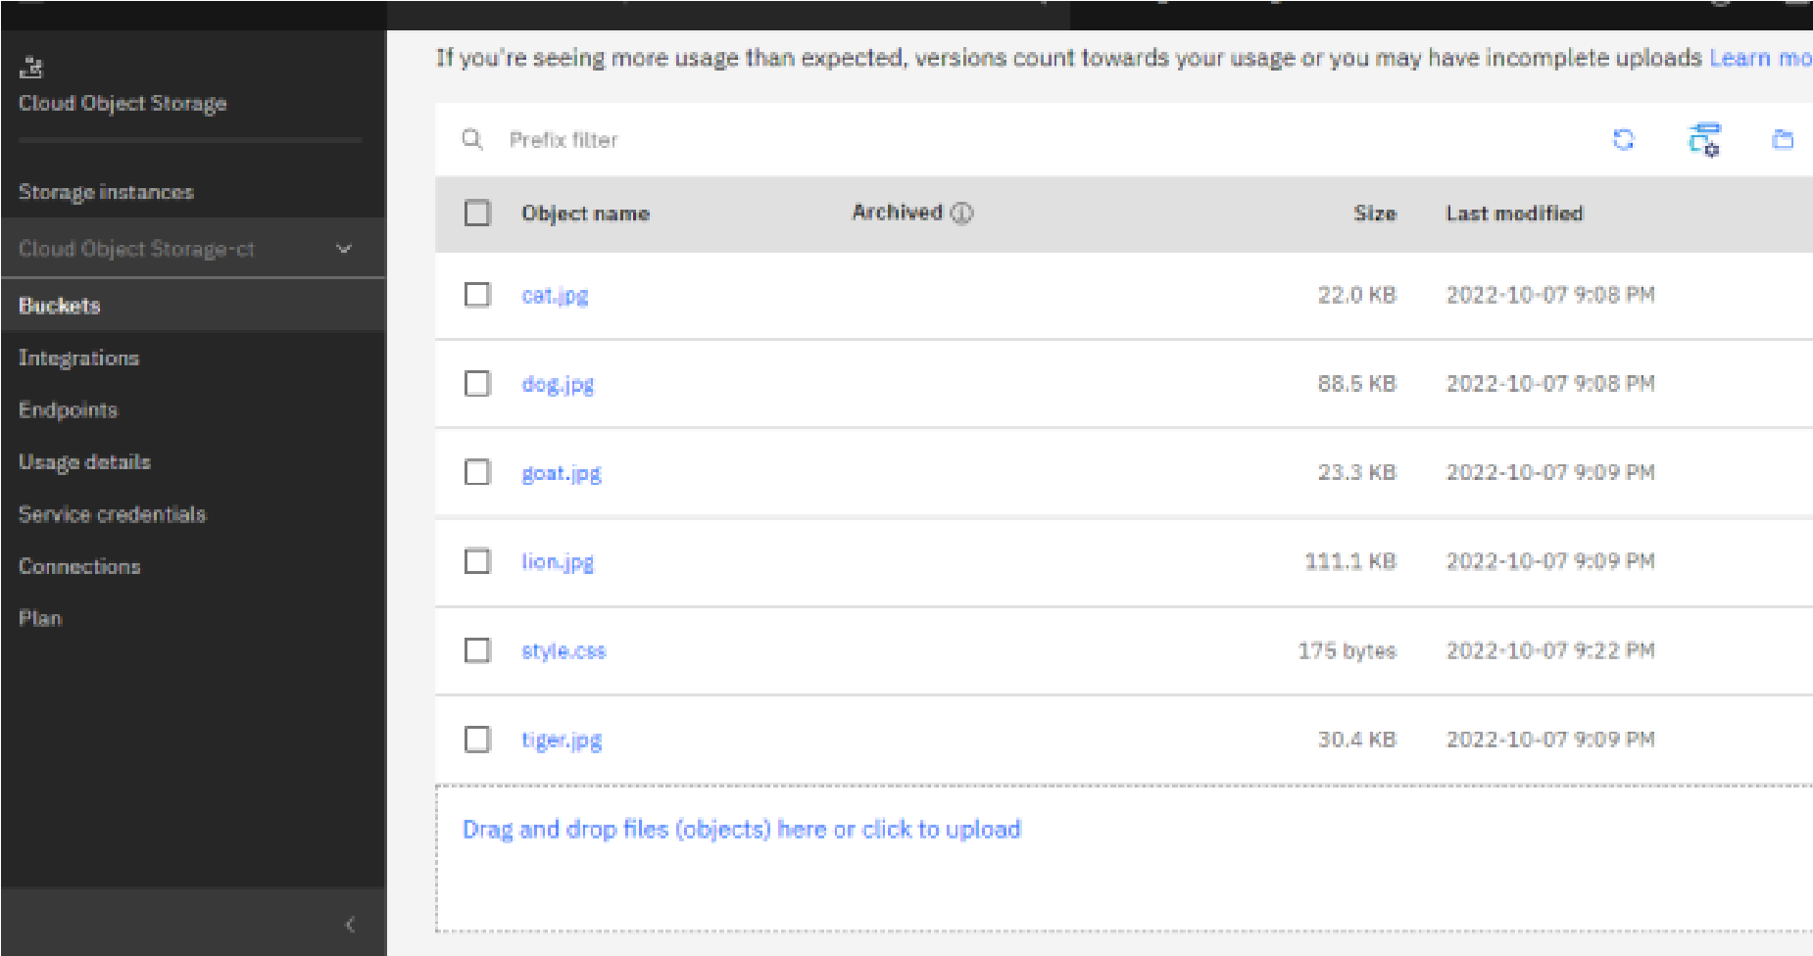

<!DOCTYPE html>

<html>

<head>

<title>

Display Images

</title>

<link rel="stylesheet" href="https://bucket0289.s3.jp-tok.cloud-objectstorage.appdomain.cloud/style.css">

</head>

<body>

<h2>Images and Style page From Cloud Object Storage </h2>

<img src="https://bucket0289.s3.jp-tok.cloud-object-storage.appdomain.cloud/cat.jpg" alt =

"cat" style="width:350px;height:450px;"></img>

<img src="https://bucket0289.s3.jp-tok.cloud-object-storage.appdomain.cloud/dog.jpg" alt =

"dog" style="width:350px;height:450px;"></img>

<img src="https://bucket0289.s3.jp-tok.cloud-object-storage.appdomain.cloud/tiger.jpg" alt =

"tiger" style="width:450px;height:450px;"></img>

<img src="https://bucket0289.s3.jp-tok.cloud-object-storage.appdomain.cloud/lion.jpg" alt =

"lion" style="width:300px;height:400px;"></img>

<img src="https://bucket0289.s3.jp-tok.cloud-object-storage.appdomain.cloud/goat.jpg" alt =

"goat" style="width:300px;height:400px;"></img>

</body>

</html>

**Question-4:**

**Design a chatbot using IBM Watson assistant for hospital. Ex: User comes with query to know the branches for that hospital in your city. Submit the web URL of that chat bot as a assignment.**

**Create Watson assistant service with 10 steps and use 3 conditions in it. Load that script in HTML page.**

**Solution:**

{

"generic": [

{

"values": [

{

"text_expression": {

"concat": [

{

"scalar": "Before we get started, I need to collect some basic information. First up, what's your **first name**?"

}

]

}

}

],

"response_type": "text",

"selection_policy": "sequential"

}

]

}

{

"generic": [

{

"values": [

{

"text_expression": {

"concat": [

{

"scalar": "Thanks! What's your **last name**?"

}

]

}

}

],

"response_type": "text",

"selection_policy": "sequential"

}

]

}

{

"generic": [

{

"values": [

{

"text_expression": {

"concat": [

{

"scalar": "Thanks!\n\nplease go through this link for more

details!\n\n[link](https://file:///C:/Users/priyanka/Desktop/sample.html)"

}

]

}

}

],

"response_type": "text",

"selection_policy": "sequential"

}

]

}

{

"generic": [

{

"values": [

{

"text_expression": {

"concat": [

{

"scalar": "The hospital Branches are

[link](https://file:///C:/Users/priyanka/Desktop/sample.html)"

}

]

}

}

],

"response_type": "text",

"selection_policy": "sequential"

} ]

}

{

"generic": [

{

"values": [

{

"text_expression": {

"concat": [

{

"scalar": "Do you have any other questions?"

}

]

}

}

],

"response_type": "text",

"selection_policy": "sequential"

},

{

"options": [

{

"label": "Yes",

"value": {

"input": {

"text": "Yes"

}

}

},

{

"label": "No",

"value": {

"input": {

"text": "No"

}

}

}

],

"response_type": "option",

"repeat_on_reprompt": true

}

]

}

{

"generic": [

{

"values": [

{

"text_expression": {

"concat": [

{

"scalar": "I would like to connect with Our Agent!"

}

]

}

}

],

"response_type": "text",

"selection_policy": "sequential"

}

]

}

{

"generic": [

{

"values": [

{

"text_expression": {

"concat": [

{

"scalar": "Thanks! It was great talking with you.Have a great Day ahead."

}

]

}

}

],

"response_type": "text",

"selection_policy": "sequential"

}

]

}

{

"generic": [

{

"values": [

{

"text_expression": {

"concat": [

{

"scalar": "I would like to connect to the Live agent! Just give me a sec!"

}

]

}

}

],

"response_type": "text",

"selection_policy": "sequential"

},

{

"options": [

{

"label": "Yes",

"value": {

"input": {

"text": "Yes"

}

}

},

{

"label": "No",

"value": {

"input": {

"text": "No"

}

}

}

],

"response_type": "option",

"repeat_on_reprompt": true

}

]

}

{

"generic": [

{

"values": [

{

"text_expression": {

"concat": [

{

"scalar": "Thank you for your Time! Hope have a good day!"

}

]

}

}

],

"response_type": "text",

"selection_policy": "sequential"

}

]

}

**Question-5:**

**Create Watson assistant service with 10 steps and use 3 conditions in it. Load that script in HTML page**.

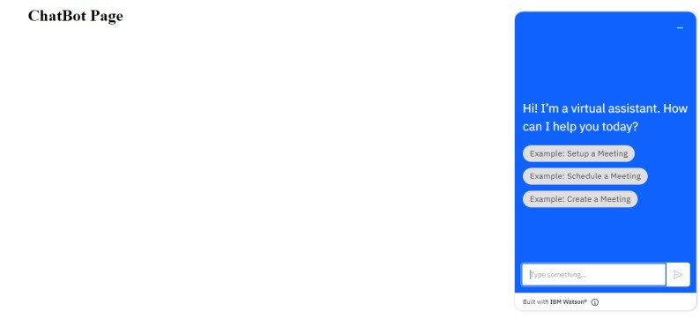

**html code:** <!DOCTYPE html>

<html>

<head>

<title>

Display Images

</title>

<link rel="stylesheet" href="style.css">

<script>

window.watsonAssistantChatOptions = { integrationID: "35636669-cd5e-400e-a10e-4a7b22fa467c", // The ID of this integration. region: "au-syd", // The region your integration is hosted in.

serviceInstanceID: "72c42f57-ebec-41d0-8ea9-da4e33c8000a", // The ID of your service instance. onLoad: function(instance) { instance.render(); }

};

setTimeout(function(){

const t=document.createElement('script');

t.src="https://web-chat.global.assistant.watson.appdomain.cloud/versions/" +

(window.watsonAssistantChatOptions.clientVersion || 'latest') +

"/WatsonAssistantChatEntry.js";

document.head.appendChild(t);

});

</script>

</head>

<body>

<h1>ChatBot Page </h1>

</body>

</html>